|  |  |  |  |  |  |  |
| --- | --- | --- | --- | --- | --- | --- |
| Description: Vertical full colour positive | Safety Bay Senior High School | | | | | |
| **CHEMISTRY UNIT 1 & 2** | | | | | | |
| **Test #4:** | | | | | | |
| **Intermolecular Forces, Solutions** | | | | | | |
|  | | | | | | |
| **NAME:** | | |  | | | |
|  | | |  | | | |
| **Time allowed for this paper** | | | | | | |
| Reading time: | | 5 minutes | | | | |
| Working time: | | 50 minutes | | | | |
|  | | | | | | |
| **Structure of this paper:** | | | | | | |
| Section | | | Number of questions | Marks available | | Marks achieved |
| Section One: Multiple Choice | | | 10 | 10 | |  |
| Section Two: Short Answer | | | 9 | 45 | |  |
|  | | |  | | **Total** | ______ / 55 |

**Section 1: Multiple Choice (10 marks)**

1. Which of the following correctly arranges the compounds in order of **increasing** polarity of bond?
   1. F2 CℓF BrF IF
   2. IF BrF CℓF F2
   3. CℓF BrF IF F2
   4. F2 IF BrF CℓF
2. Which of the molecules is non-polar but contains polar covalent bonds?
   1. Oxygen, O2
   2. Sulfur dioxide, SO2
   3. Tetrachloromethane, CCℓ4
   4. Ammonia, NH3
3. For the substances C (graphite), O2, C3H8 and C2H5OH, which of the following represents them in order of **increasing** melting point?
   1. O2­ C3H8 C2H5OH C
   2. C3H8 O2 C2H5OH C
   3. O2 C C3H8 C2H5OH
   4. O2 C C2H5OH C3H8
4. In general, what can be said about the surface tension and vapour pressure of substances which have particularly **weak** intermolecular forces?
   1. Surface tension: High Vapour pressure: Low
   2. Surface tension: High Vapour pressure: High
   3. Surface tension: Low Vapour pressure: Low
   4. Surface tension: Low Vapour pressure: High
5. Which type of bonding is **NOT** present in solid hydrogen chloride (HCℓ)?
   1. Covalent
   2. Dipole-dipole
   3. Dispersion force
   4. Hydrogen bonding
6. The boiling point of a family of trihalomethanes (CHX3) are listed below:

Tetrafluoromethane CHF3 -89 °C

Tetrachloromethane CHCℓ3 61 °C

Tetrabromomethane CHBr3 150 °C

Tetraiodomethane CHI3 330 °C

The increase in boiling points moving down the list is due to an increase in the strength of:

* 1. Covalent bonding
  2. Dispersion forces
  3. Dipole-dipole bonding
  4. Hydrogen bonding

The next two questions refer to the following graph showing the solubility of two substances over a range of temperatures.

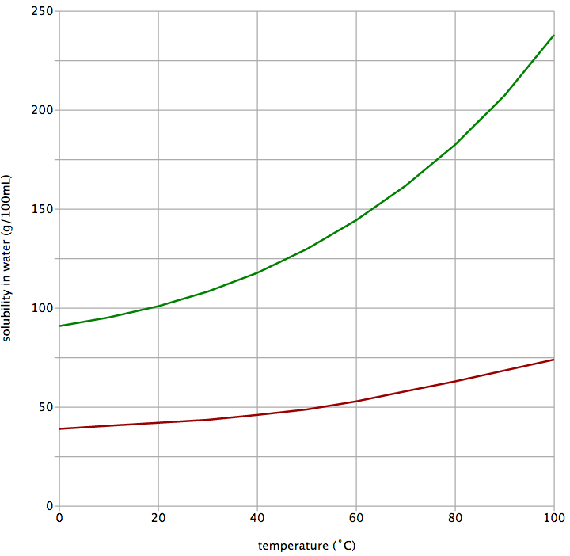

III

II

I

Copper(II) sulfate

Potassium nitrate

1. If you initially had 50 g of potassium nitrate dissolved in 300 mL of water at 20 °C, how much **additional** potassium nitrate would you be able to dissolve in this solution?
   1. 50 g
   2. 100 g
   3. 250 g
   4. 300 g

1. Which point of the graph represents a supersaturated solution of copper(II) sulfate??
   1. Point I
   2. Point II
   3. Point III
   4. This cannot be determined without knowing the volume of water
2. The concentration of sodium hypochlorite, NaCℓO, in White Cling hospital-grade disinfectant is 52.5 g L-1. A company wished to produce 500 two-litre bottles of the disinfectant.

Which of the following formulas correctly calculates the mass of sodium hypochlorite needed by the company?

1. Consider the following TLC plate of compounds X, Y and Z developed using a non-polar mobile phase on a polar stationary phase.

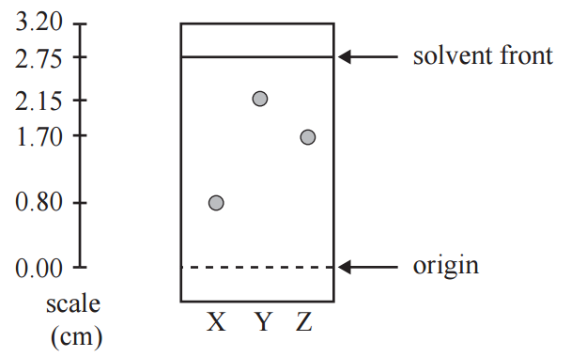

The Rf value of the most polar component in this TLC separation is:

* 1. 0.29
  2. 0.78
  3. 0.80
  4. 2.15

**Section 2: Short Answer (50 marks)**

1. **(9 marks)**

For each of the species listed below:

* draw the structural formula, representing **all** valence shell electron pairs as : or as – (3 marks)
* draw **and** name the shape of the molecule (3 marks)
* state the polarity of the molecule (3 marks)

|  |  |  |  |  |
| --- | --- | --- | --- | --- |
| **Species** | **Structure (showing all valence shell electrons)** | **Drawing**  **of shape** | **Name**  **of shape** | **Polarity of  molecule**  (polar or  non-polar) |
| Water  (H­2O) | ··  H — O — H  ·· | O  H H | Bent | Polar |
| Carbon disulfide  (CS2) |  |  |  |  |
| Phosphorus tribromide  (PBr3) |  |  |  |  |
| Difluoromethane  (CH2F2) |  |  |  |  |

1. **(7 marks)**

Compare the vapour pressure and density of liquid water to the other named substances. Justify the reasoning behind your prediction, using diagrams where appropriate.

1. Compared to pentane (C5H12), the **vapour pressure** of liquid water is: (3 marks)

higher equal lower

**Explanation:**

1. Compared to solid water (ice), the **density** of liquid water is: (4 marks)

higher equal lower

**Explanation** (including a supporting diagram)**:**

**Diagram:**

1. **(7 marks)**

Formaldehyde is a toxic chemical used in the production of resins. It has the molecular formula of CH2O. The structure of formaldehyde is shown below:

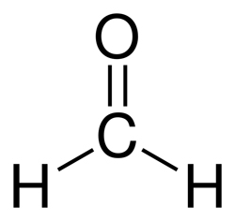

1. On the above diagram, show the ‘lone pairs’ of electrons possessed by this molecule. (1 mark)
2. Explain why formaldehyde has the trigonal planar shape represented in the image above.

(2 marks)

1. Formaldehyde is described as a ‘polar molecule’. Explain why this is so. (3 marks)

1. Salts such as sodium chloride dissolve in polar solvents like formaldehyde. Name the type of attractive force that allows sodium chloride to dissolve in formaldehyde. (1 mark)

1. **(6 marks)**

For each of the following molecule pairs:

1. Circle the molecule with the highest boiling point
2. Give a brief explanation for your choice
3. carbon dioxide (CO2) OR sulfur dioxide (SO2) (3 marks)

**Explanation:**

1. bromine (Br2) OR iodine (I2) (3 marks)

**Explanation:**

1. **(5 marks)**

Paracetamol is a commonly used painkiller. The partial equation below shows one method of preparing paracetamol.

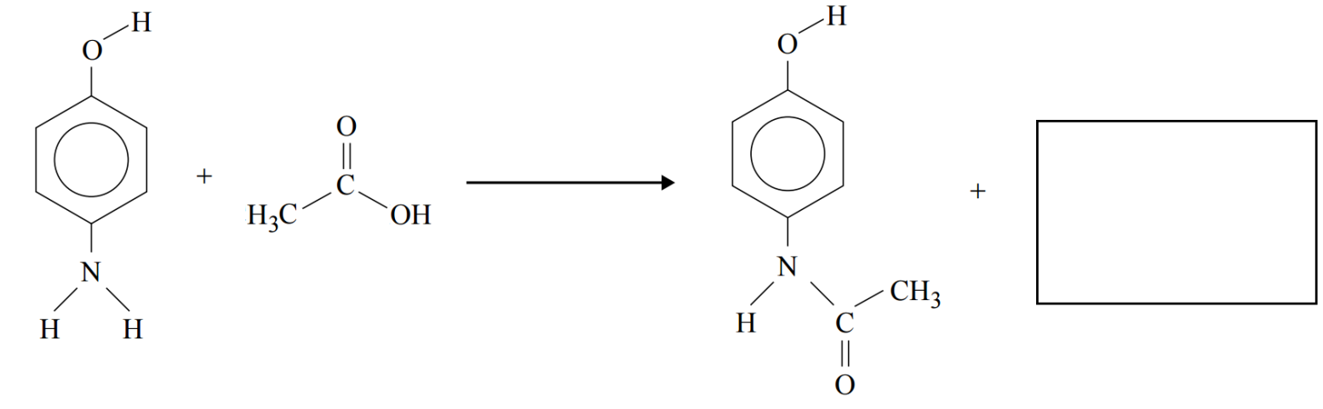4-aminophenol ethanoic acid paracetamol

1. Complete the equation above by showing the formula or structure of the other substance formed during this reaction. (1 mark)
2. Explain in terms of intermolecular forces, whether you would expect paracetamol to be soluble in water. Include a diagram showing interactions between paracetamol and water molecules. (4 marks)

**Diagram:**

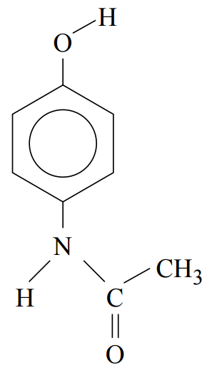

1. **(4 marks)**

On Earth, water evaporates, forms clouds and falls back to the ground in a process known as the ‘water cycle’.

On Saturn’s moon Titan, where the average temperature is -178 °C, methane (CH4) behaves the same way as water does on Earth, evaporating and raining onto the surface as a liquid.

Using your knowledge of their structure and bonding, explain why water and methane undergo these processes at such different temperatures.

1. **(2 marks)**

Oxalic acid, H2C2O4•2H2O, is a toxic substance found in rhubarb leaves. Solutions of oxalic acid are used in the dying and bleaching industries.   
  
What is the concentration, in mol L-1, of an oxalic acid solution of 10.2 g of oxalic acid dissolved in 200 mL of solution?

1. **(3 marks)**

A group of students wanted to measure the rate of reaction between magnesium and hydrochloric acid at different temperatures. The equation for the reaction is:

Mg + 2 HCℓ 🡪 MgCℓ2 + H2

In order to avoid conflicting results, the students wanted to ensure that they had sufficient acid to react with all of the magnesium.

What volume of 0.1 mol L-1 acid would be required to completely react with 1 g strips of magnesium?

1. **(2 marks)**

Caffeine is a stimulant drug that is found in coffee, tea, energy drinks and some soft drinks. The concentration of caffeine in drinks can be determined using HPLC.

Four caffeine standard solutions containing 50 ppm, 100 ppm, 150 ppm and 200 ppm were prepared. 25 μL of each sample was injected into the HPLC column. The peak areas were measured and used to construct the calibration graph below. The chromatograms of the standard solutions each produced a single peak at a retention time of 96 seconds.



25 μL samples of various drinks thought to contain caffeine were then separately passed through the HPLC column. The results are summarised below.

|  |  |  |
| --- | --- | --- |
| **Sample** | **Retention time of  major peak (seconds)** | **Peak area of largest peak** |
| Soft drink A | 96 | 12 000 |
| Soft drink B | 32 | 8 500 |

1. What is the concentration, in ppm, of caffeine in soft drink A? (1 mark)



1. What evidence is presented in the chromatogram that supports the conclusion that soft drink B does not contain any caffeine? (1 mark)